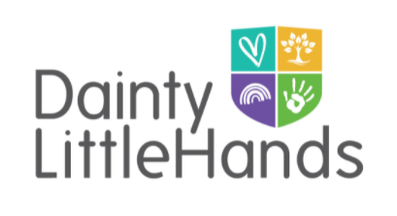

Smoking, Alcohol and Drugs

Smoking
Smoking, including vaping, is not permitted anywhere on the premises of Dainty Little Hands Ltd., including outside play areas. This rule applies to everyone including staff, people collecting children or any other visitors.
If we discover that a child has cigarettes in their possession while at the Setting, we will confiscate the cigarettes and notify their parent or carer at the end of the session.

Alcohol
Anyone who arrives at the Setting clearly under the influence of alcohol will be asked to leave immediately. If they are a member of staff, disciplinary procedures will follow.
If we discover that a child has alcohol in their possession while at the Setting, we will confiscate it and notify their parent or carer at the end of the session.
Staff are asked not to bring alcohol onto the Setting’s premises.

Drugs
Anyone who arrives at the Setting clearly under the influence of illegal drugs will be asked to leave immediately. If they are a member of staff, serious disciplinary procedures will follow.
If we discover that a child has illegal drugs in their possession while at the Setting, we will inform their parent or carer.
If a member of staff is taking prescription drugs that may affect their ability to function effectively, they must inform the Setting Manager and Support Manager(s) as soon as possible and seek medical advice. The Setting Manager and Support Manager(s) will then complete a risk assessment. Staff medication on the premises will be stored securely and out of reach of children at all times.
Safeguarding children
All members of staff have a duty to inform the Setting manager and the Designated Safeguarding Lead (DSL-Jayne Dainty) if they believe that a parent or carer is a threat to the safety of a child due them being under the influence of alcohol or illegal drugs when they drop off or collect their child. The Setting Manager and DSL will decide upon the appropriate course of action.
If a parent or carer is clearly over the alcohol limit, or under the influence of illegal drugs, staff will do their utmost to prevent the child from travelling in a vehicle driven by them. If necessary, the police will be called.

Related policies
Staff Disciplinary policy, Child Protection and Safeguarding policy.
This policy was adopted by: Dainty Little Hands Ltd | Date: 25/08/2022
Reviewed :
01/08/2023
01/08/2025
To be reviewed: 01/08/2024 | Signed: JAYNE DAINTY

Written in accordance with the Statutory Framework for the Early Years Foundation Stage (2024): Safeguarding and Welfare Requirements: Child protection [3.4], Safety and suitability of premises, environment and equipment [3.56] and Suitable people [3.19].

