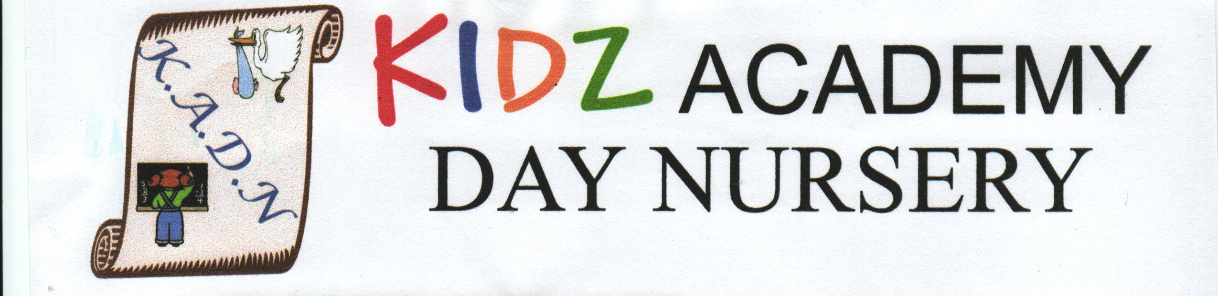

TRANSPORTATION OF CHILDREN
AND SAFETY ON OUTINGS

We recognise the potentially serious hazards that arise when children are transported by road and are away from the nursery premises.

It is our policy to ensure that

- Children are transported safely in road worthy vehicles by competent drivers that have insurance. (A copy of their insurance must be obtained before confirming to use the company).

- All children and adults are restrained in seat belts when travelling in minibuses.

- Maximum seating is not exceeded.

- Senior staff will ask the venue if there are any hazards which they need to include on their trip risk assessment form i.e. is there road works outside the venue that may require the minibus to park somewhere else than the car park etc.

- A senior member of staff will travel to the venue a day or so before the trip to see if there are any hazards on the journey, if there are, these will be documented on the risk assessment form along with solutions i.e. alternative routes or added safety measures in place. Alternatively, you can get the venue to send their own risk assessment.

- Parents/guardians are informed of all the necessary information regarding the trip in advance.

- Staff ratios on outings conform or exceed the requirements of Ofsted.

- Children are only taken to venues that we consider to be safe and appropriate.

- Our team will take the nursery mobile phone in order to use in emergencies or to keep in regular contact with the nursery.

- On trips we need to take the following information: -

- Health problems for both the children and adults that are to go onto the trip
- Dietary requirements of the children if necessary
- Medication and emergency medication for both children and adults along with medication forms and the medication book.
- Accident books for children and adults
- Emergency medical report forms
- Managing an emergency form with the number of the mobile phone they will be using whilst on the trip as well as details of the venue i.e. address.
- Parent/guardian contact numbers.

- All staff are to wear identification badges and uniform when on trips so they can be recognised by the children.

- All children on the outing must wear badges with the name and number of the nursery on them. (Do not put the children’s names on the badges as we do not want strangers to know this information).

- Children wear high visibility vests, so they are easy to see by all.

- Staff must complete either the pram walk checklist or the trips safety checklist before leaving the nursery premises.

- Staff must complete a venue risk assessment form before leaving the nursery premises.

- Senior staff must implement head counts at certain points of the day i.e. on and off the transport, before and after meals, before and after toilet breaks etc.

- All adults must know the fire evacuation point of the venue.

- The lost child procedure needs to be taken on all trips and kept safe by the Senior Member of Staff in charge. The procedure needs to be read by each adult attending the trip before going onto the trip.

Reviewed: 09/08/2024 Next Review Date: July 2025

LOST CHILD PROCEDURE

In the event of losing a child whilst on a trip these are necessary procedures to
follow: -

- Inform the management of the venue (so they can if appropriate announce the child’s name and where their party is waiting for them).

- Contact the Nursery to see if anyone has found the child and contact the nursery due to reading the lost child’s identification badge.

- Do not leave the area in case the child returns.

- One member of staff should go back to the car park or entrance area as the child may go back there.

- Notify the parents/guardians

- Notify the police by calling 999.

- Record all events in details and pass on the DSL.

Reviewed: June 2024 Next Review Date: June 2025

