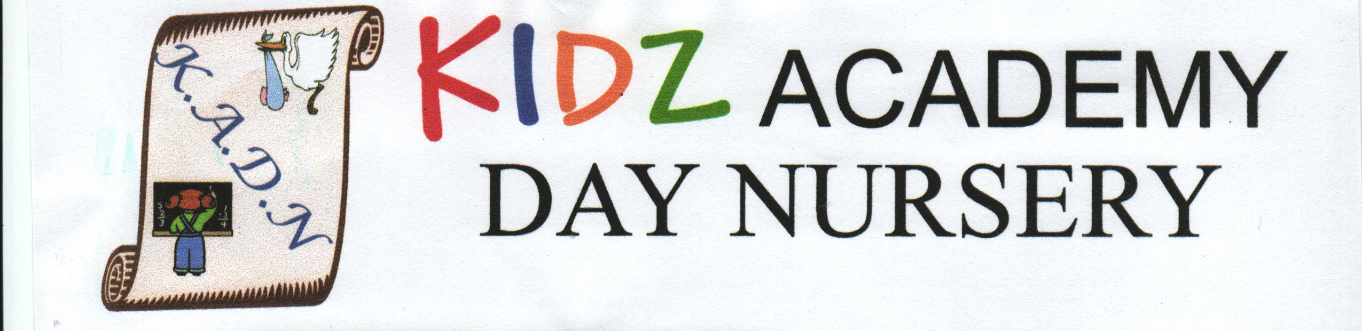

SUN PROTECTION POLICY

INTRODUCTION
To develop this policy we have incorporated guidance from the Cancer Research UK’s Sun Smart Guidelines Campaign and the National Eczema Society 2010. The aim of this policy is to ensure that we can all enjoy the sun safely over the summer season.
Protection from the sun is important because skin cancer is now the second most common cancer in the U.K. Children are particularly vulnerable as their skin is delicate and easily damaged. Many skin cancers result from sun damage acquired during childhood.
Young children are unable to take responsibility for their own sun protection, so we have a duty to protect them from the harmful effects of the sun at all times, when they are attending nursery as well as when they are at home.
All children regardless of skin colour, are at risk of skin cancer, it is important that this policy applies to all children, irrespective of skin colour.
RESPONSIBILITIES OF THE STAFF TEAM AND PARENTS
It is important the team and parents/guardians work in partnership with each other in order to protect the children’s health and welfare.
Responsibilities of the Staff Team
- Teach children how to protect themselves from the sun in order to reduce the risk of skin cancer.

- Engage children in activities that promote safe sun behaviour i.e. at circle time talk about the importance of protection from the sun and how we can achieve this. Use resources such as books and puppets to reinforce this information.

- Liaise with parents/guardians in order to work together for the protection of children.

- Act as good role models for children, for example by wearing hats and sunscreen when outside.

- Ensure parents/guardians have signed consent forms for their child to wear sunscreen and have it applied by staff as necessary.

- Ensure that children are not allowed out to play unless they are wearing sunscreen and are suitably clothed.

- Ensure children always have access to drinks throughout the day.

- Report any difficulties with these procedures to the Manager.

Responsibilities of the Parent/Guardian
- As your child’s main carer, you have the prime responsibility for their health and welfare.

- To be aware of the Dainty Little Hands @ Kidz Academy Sun Protection Policy.

- Work with the team to jointly ensure that children never get burned – ensure children are suitably dressed for sunny weather between April and September i.e. cover your child’s shoulders by providing them with t-shirt’s instead of strappy tops, no open toe shoes/sandals or jelly shoes etc.

- Provide minimum SPF25+ (or higher) preferably SPF50+ sunscreen cream for nursery to use, labelled with your child’s name and the date the product was opened.

- Sign consent forms for staff to apply sunscreen as and when necessary.

- Apply sunscreen to your child before they arrive at nursery as the sunscreen should be applied an hour before going outside and reapplied frequently throughout the day.

- Provide wide brimmed sun hats or legionnaire style with neck protection.

- Provide UV protective sun glasses if possible.

USING SUNSCREEN
- Ensure all sunscreen has been labelled with the child’s name and date it was opened. (Sunscreen cream needs to be replaced annually as its strength is reduced to 50% after 12 months).

- Sunscreen should be applied by the parent/guardian in the morning as sunscreen needs to be applied an hour before going outside. The nursery team need to reapply sunscreen regularly throughout the day particularly at midday.

- Encourage and supervise older children applying sunscreen themselves with the help of mirrors. The team will need to apply the sunscreen where children cannot do it for themselves.

- Ensure the sunscreen is spread evenly over exposed areas of skin. Please pay particular attention to areas that burn easily such as the ears and neck, rub it in well.

INFORMATION FROM NATIONAL ECZEMA SOCIETY 2010
- Emollient should be applied about half an hour before applying a sunscreen. This will stop the sunscreen from becoming diluted by the emollient and will make sure that the sunscreen keeps its protective properties. Apply emollient and sunscreen, stroking gently in the direction of the hair growth. Do not rub as this will set off itching.

- If you are applying a moisturiser that is greasy or oily, be careful not to overdo the application of the moisturiser as this can cause a ‘frying’ effect.

- Certain medication such as antihistamines and antibiotics can cause the skin to become more sensitive to sunlight. Other medications for more severe eczema will necessitate the need to avoid sunlight and the use of sunblock.

- Heat is often a key factor in triggering eczema. Covering up in light trousers and tops will not only protect against sun exposure but will help to keep the child cool. Natural fibres, such as cotton and linen, are preferable to synthetic fabrics which can make the child feel hot and sweaty.

- Sunscreens can irritate eczema in some people. Parents/guardians should discuss choice of product with a pharmacist.

- Children with eczema can have their sunscreen prescribed by their doctor.

REVIEW OF POLICY
The sun protection policy is reviewed annually unless new legislation is issued indicating the policy is updated immediately.

Reviewed: 09/08/2024 Next Review Date: July 2025

Dear Parents/Guardians
Now the summer term has started I would like to take this opportunity for us to work together to protect the children from the damaging effects the sun can cause. The sun rays are very strong over the summer months and they can damage children’s skin. This may not seem like a problem right now, but sadly it can lead to skin cancer in later life. Your child’s health and well-being are very important to us, so below details the procedures which we need to implement in order to protect your child from the harmful damage of the sun.
All children are to wear a hat when they play outside. Please send your child to nursery wearing a comfortable wide brimmed hat or legionnaire (cap with neck protection) – with your child’s name on – and ensure that they are wearing clothing that protects the skin i.e. t-shirts instead of strappy tops etc. Also no open toe sandals or jelly shoes.
We request that you provide a high factor sunscreen (SPF 50 + is the best to protect your child). The nursery team will supervise children applying sunscreen and help those that are not able to apply sunscreen by themselves. In order for your child to be included in outside play during the summer months, please return the sunscreen consent form which is attached along with a bottle of factor 25+ or 50+ sunscreen clearly labelled with your child’s name and the date the sunscreen was opened .
If the sunscreen is 12 months old then we would recommend it to be replaced by a new one as its strength will be reduced by 50% indicating it will be less effective in providing your child with protection. Professionals recommend that sunscreen is applied an hour before you go outside indicating if you apply the first dose before your child arrives at nursery and the nursery team will frequently apply the sunscreen throughout the day as and when necessary.
For more information regarding sun protection I have attached the nursery’s policy for you to read at your leisure.
Your support is very important in order for our policy to work. You can help by:
- Talking to your child about the importance of sun protection at home.
- Remembering to send your child to nursery with a wide brim hat.
- Send in factor 25+ sunscreen or higher, labelled with your child’s name.
- Complete the attached consent form so that we have a record of your support for the sun safety policy and your wishes with regard to sunscreen use.
Together I hope we can have a very happy and safe term to come
Many Thanks

SUNSCREEN CONSENT FORM

Name of Child:
Date of Birth:
I have read and support the nursery’s Sun Protection Policy.
- I will apply sunscreen to my child an hour before they arrive at nursery.
- I will provide a spare non-aerosol SPF25+/50+ sunscreen product for my child/ren.
- I will ensure my child is wearing appropriate clothes for the hot weather (i.e. t-shirts instead of strappy tops to protect my child’s shoulders, light material clothes for my child to keep cool, no open toe sandals or jelly shoes etc)
- I will provide a wide brim hat or a cap with neck protection (legionnaire) which will be labelled with my child’s name.
I give my consent for the nursery team at Dainty Little Hands @ Kidz Academy to apply sunscreen when this is considered necessary.

Parent Name (Print):
Signature:
Date:

